Solution
- Here, the course grade is dependent variable and placement test score is independent because, course grade is dependent on placement test score. Further placement test is occurred at first and final course exam held latter.
- Scatter Diagram
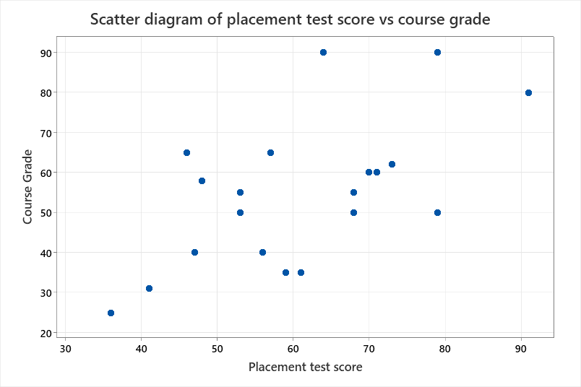
Conclusion: The scatter diagram shows that there is moderate degree of positive correlation between placement test score and course grade. The graph also shows some extreme values
(c) Karl Pearson’s correlation coefficient

Method
Correlation type | Pearson
Number of rows used | 20

Correlations
 | Course Grade
Placement test score | 0.602

Conclusion: Since Karl Pearson’s correlation is +0.60 , we conclude that there is a moderate degree of positive correlation between.
(d) Spearman’s rank correlation coefficient
Method
Correlation type | Spearman
Number of rows used | 20

Correlations
 | Course Grade
Placement test score | 0.519

Conclusion: There is moderate degree of positive correlation coefficient between course grade and placement score. Spearman’s correlation coefficient is slightly lower than Karl Pearson’s correlation coefficient.
(e) Appropriateness of simple linear regression model
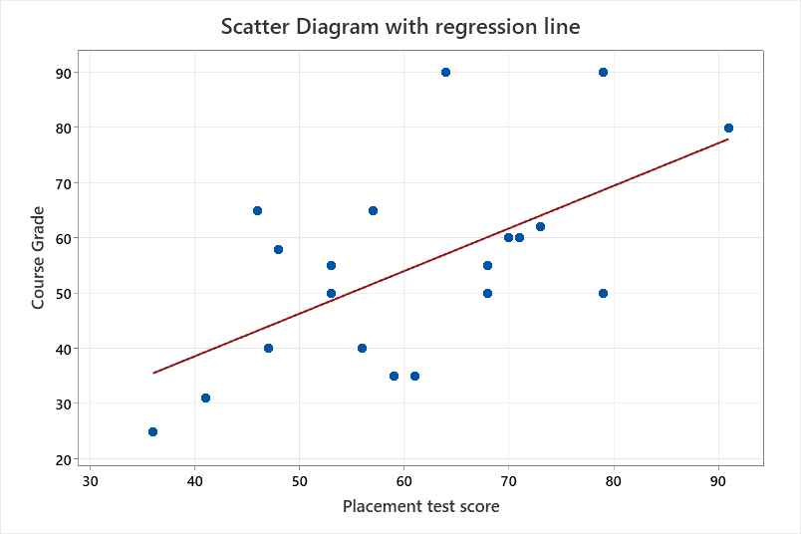
The graph shows that the simple linear regression is the plausible model for this data because, the dots show the linear tendency, there is greater scatterness in the data and some extreme values.
(f) Fitting of Regression Equation
Regression Equation
Course Grade | = | 7.8 + 0.771 Placement test score

Coefficients
Term | Coef | SE Coef | T-Value | P-Value | VIF
Constant | 7.8 | 15.1 | 0.52 | 0.613
Placement test score | 0.771 | 0.241 | 3.20 | 0.005 | 1.00
(g) Interpretation of intercept (bo)
Here bo = 7.8
Conclusion: If there is no placement test the student likely to get an average course grade of 7.8
Interpretation of slope (b1)
Here, b1 = 0.77,
Conclusion: It means that for every unit increment in the placement score, course grade increases in average by an amount of 0.77
(h) Predict course grade of a student who scored 80 in the placement test
Course grade = 7.8 + 0.77 x placement score = 7.8 + 0.77 x 80 =
- Coefficient of determination
Model Summary
S | R-sq | R-sq(adj) | R-sq(pred)
14.8015 | 36.22% | 32.68% | 23.19%
Here coefficient of determination is 36.22 %. It means that roughly 32 % variation in course grade is explained by simple linear regression equation fitted earlier. Remaining 68 % variation in the course grade is explained by the factors other than placement score. Hence, the fitted equation is not reliable. It further tells that we need more independent variables in the model.
(j) Standard error of estimation
Since standard error of estimate is high (S = 14.80), hence there is greater variability of dots around the regression line, indicating poor fitting of regression.
(k) Residual analysis
Graph of residuals
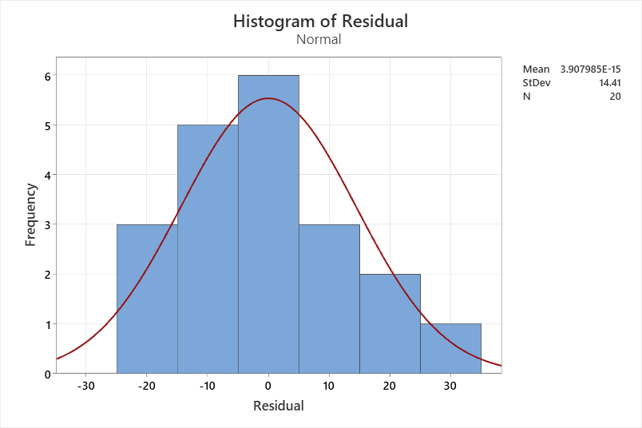

Residual distribution is right skewed. Violation of the assumption that error distribution is normal

Graph of fits vs residual
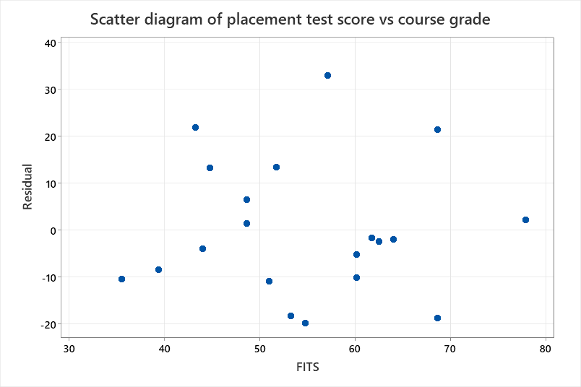

- There is linear relationship between dependent variable and independent variable since there dots are roughly in random pattern above and below the e = 0 line.
- There is presence of Heteroscedascity in the data. It violates the assumption that variance of distribution of Y across different values of X is same.
Graph of residual vs observation order
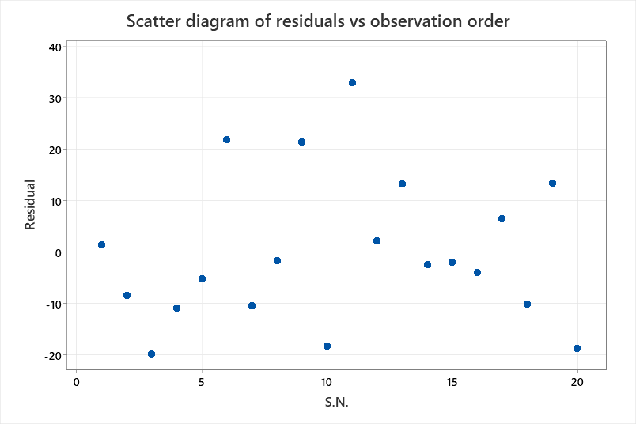

Conclusion: There is tendency in the residuals as most of the residuals are tend to be positive. Hence there might be possibility that residuals are correlated and most likely positively correlated.

